User Manual

1. Git clone “https://github.com/ziyingb/webimperators”
2. Download MySQL Workbench 8.0 CE
3. Set up new connections

1. Connection name – webimperators
2. Hostname – remain default (127.0.0.1)
3. Port – remain default (3306)
4. Username – root
5. Password – toor

Once details entered correctly, click ‘OK’.

1. Create Database using SQL Query

CREATE DATABASE webimperators;

USE webimperators;

CREATE TABLE `user` (

`userid` int NOT NULL AUTO_INCREMENT,

`email` varchar(50) NOT NULL,

`password` varchar(50) NOT NULL,

`username` varchar(50) DEFAULT NULL,

`secret` varchar(50) DEFAULT NULL,

PRIMARY KEY (`userid`)

) ENGINE=InnoDB AUTO_INCREMENT=0 DEFAULT CHARSET=utf8mb4 COLLATE=utf8mb4_0900_ai_ci;

CREATE TABLE `img_dataset` (

`img_id` int(11) NOT NULL,

`img_person` varchar(3) NOT NULL

) ENGINE=InnoDB DEFAULT CHARSET=latin1;

CREATE TABLE `prs_mstr` (

`prs_nbr` varchar(3) NOT NULL,

`prs_name` varchar(50) NOT NULL,

`prs_active` varchar(1) NOT NULL DEFAULT 'Y',

`prs_added` datetime NOT NULL DEFAULT CURRENT_TIMESTAMP

) ENGINE=InnoDB DEFAULT CHARSET=latin1;

ALTER TABLE `img_dataset`

ADD PRIMARY KEY (`img_id`);

ALTER TABLE `prs_mstr`

ADD PRIMARY KEY (`prs_nbr`);

1. Install libraries

Open command-line tool(cmd).

Type “pip install -r requirements.txt”

1. Change directory

Change the directory to where the dataset images to be saved.

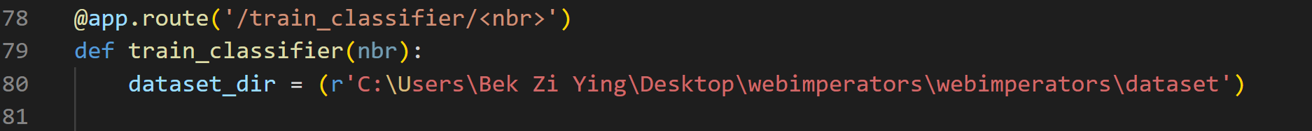

1. Run Program

In cmd, type “python app.py”.

Open <http://127.0.0.1:5000> in browser.

If successful, the index page will be shown as above.

1. Prepare webcam

Make sure your camera on your computer is open.

1. Prepare phone

Make sure you have a working smartphone.

Download Google Authenticator app.